Introduction

This article describes how to run and test ASP.NET Core Web API Docker container using Docker Desktop.

**Topics covered**

This article demonstrates how to build the following:

* Create a simple ASP.NET Core Web API
* Create a Docker image using Visual Studio
* Build and run Docker container locally

**Pre-requisites**

1. [Download](https://visualstudio.microsoft.com/downloads/) and install Visual Studio 2019.
2. [Download](https://www.postman.com/downloads/) and install Postman.
3. [Download](https://www.docker.com/products/docker-desktop) and install Docker Desktop.

**Tools**

1. Visual Studio 2019
2. Docker
3. Postman

**Related Resources**

1. [Create a web API with ASP.NET Core](https://docs.microsoft.com/en-us/aspnet/core/tutorials/first-web-api?view=aspnetcore-5.0&tabs=visual-studio)

Task 1 - Create a simple ASP.NET Core Web API

In this task, you will see how to create a new simple ASP.NET Core Web API using Visual Studio 2019.

**Step 1**

Open Visual Studio 2019, click **Create a new project**.

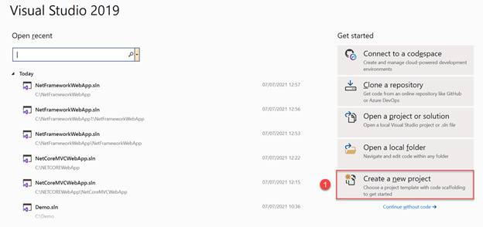

**Step 2**

Search ASP.NET in the search bar, select **ASP.NET Core Web API** project template and click **Next**.

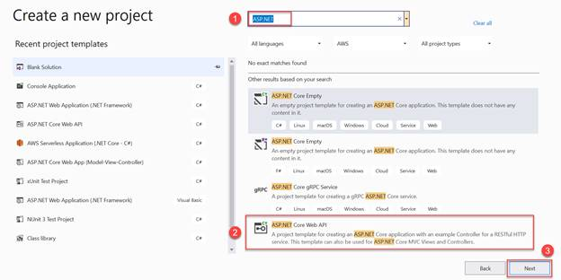

**Step 3**

Enter the project name as *DemoCoreWebAPI.* Click**Next.**

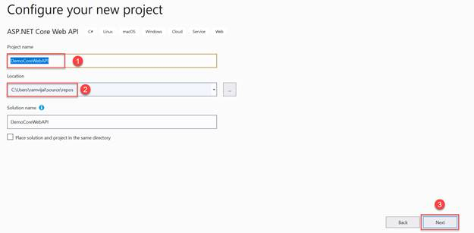

**Step 4**

Select .NET 5.0 (Current) as Target Framework. Click **Create**.

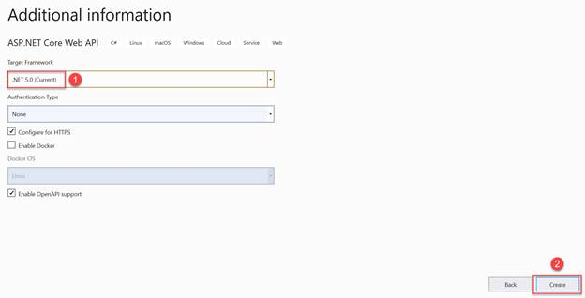

**Step 5**

Expand **Controller** folder in the solution explorer, right click *WeatherForecastController.cs file* and click **Delete**. Right click *WeatherForecast.cs* file and click **Delete**.

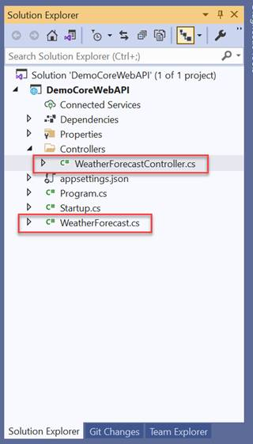

**Step 6**

Right click **Controllers** folder, click **Add** and then click **Controller**.

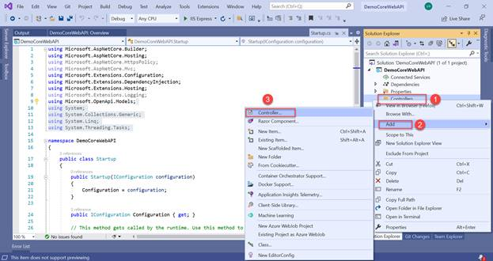

**Step 7**

Select **API-> API Controller with read/write actions**. Click **Add**.

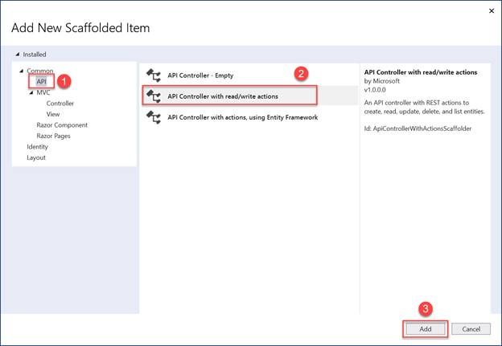

**Step 8**

Leave the default name and click **Add**.

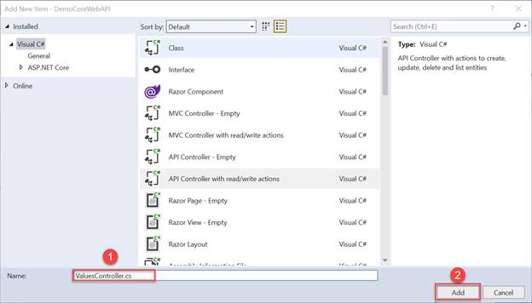

**Step 9**

Hit F5 to run the API locally and Swagger will be displayed. Try out the default endpoints.

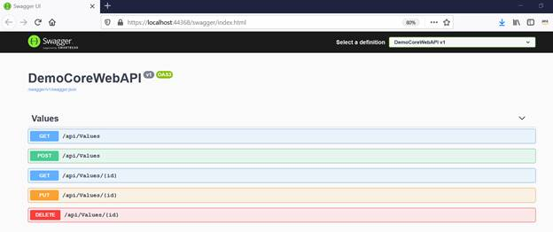

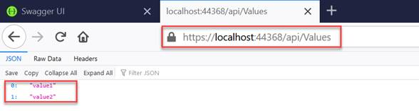

Task 2 - Create a Docker image using Visual Studio

In this task, you will see how to create a Docker image for ASP.NET Core Web API using Visual Studio 2019.

**Step 1**

In the solution explorer, right click on the project, click **Add**->**Docker Support**.

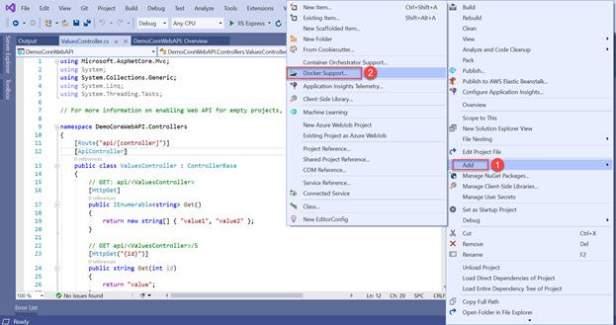

**Step 2**

Select **Linux** as Target OS. Docker file is created as shown below.

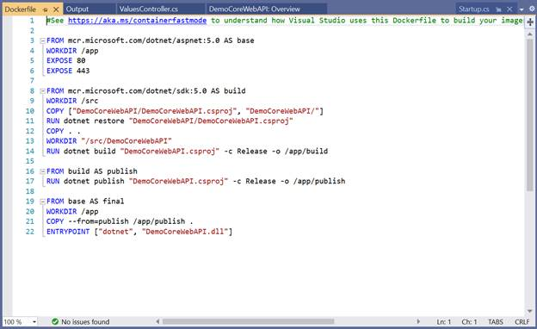

Task 3 - Build and Run Docker container Locally

In this task, you will see how to build and run Docker image inside container locally using Docker Desktop. **Note:** I am using Windows machine.

**Step 1**

Open command prompt.

**Step 2**

Navigate to solution folder. Make sure Docker file is available in solution folder location or else copy the generated Docker file and place it in the location where the solution file is available.

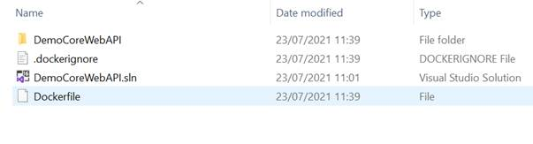

**Step 3**

Execute the below command to create the Docker image.

*docker build -t aspnetcorewebapiimage -f Dockerfile .*

**Step 4**

Execute the below command to view all the Docker images.

*docker images*

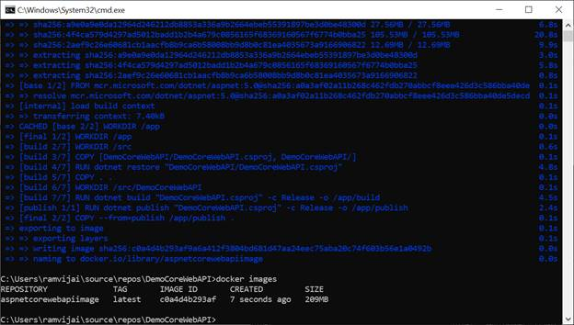

**Step 5**

Execute the below command to create and run a container.

*docker run -d -p 8080:80 --name aspnetcorewebapicontainer aspnetcorewebapiimage*

**Step 6**

Open Docker desktop, click **Containers/Apps**. You can see a new container named *aspnetcorewebapicontainer* running as shown below.

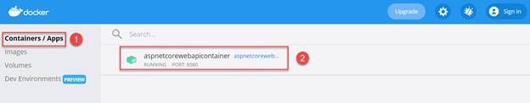

**Step 7**

Open browser and enter the following URL to get the results.

*http://localhost:8080/api/values*

